**REST - Country Web Service**

**URL**: /country

**Sample Request**: http://localhost:8083/country  
**Sample Response**:

{

  "code": "IN",

  "name": "India"

}

* What happens in the controller method?

Executes  **/country** GET request. Loads **country.xml** and fetches **countryIN bean**.

* How the bean is converted into JSON reponse?

Spring Boot auto-converts Java object (Country) to JSON using Jackson.

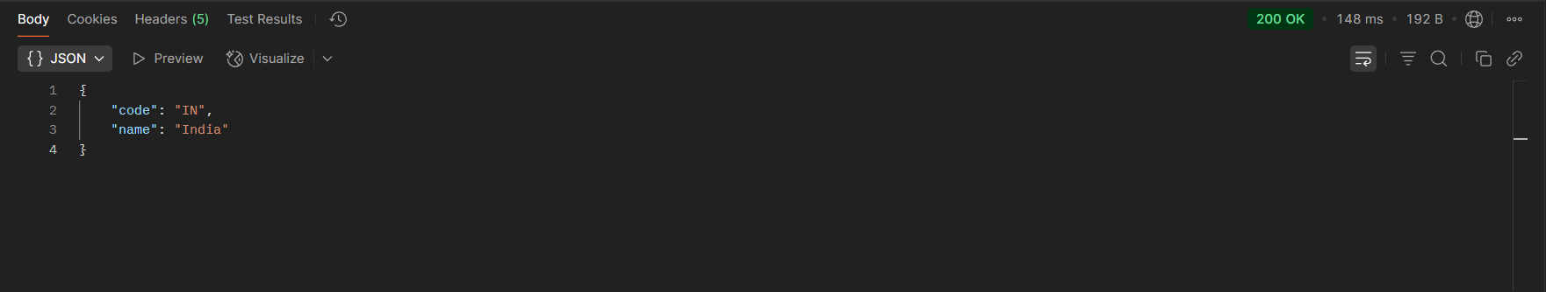

* In network tab of developer tools show the HTTP header details received

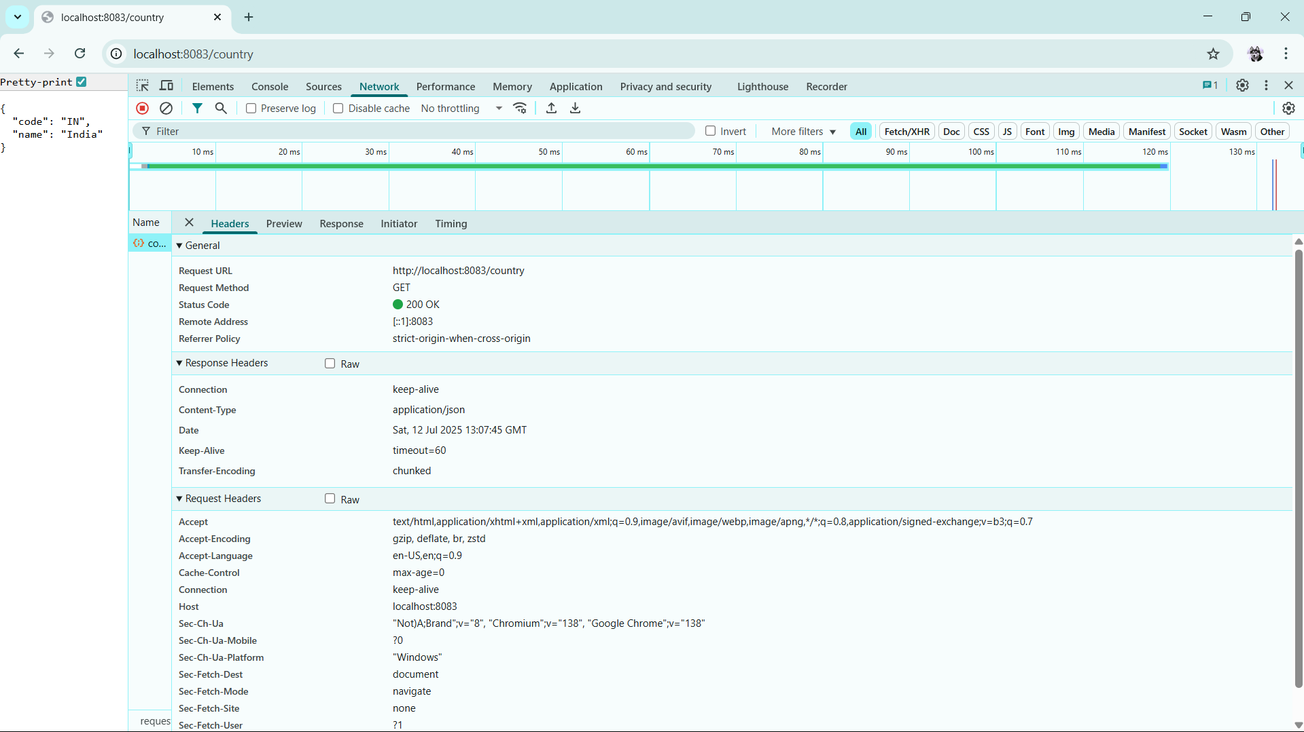

* In postman click on "Headers" tab to view the HTTP header details received

